Paper Title (use style: paper title)
Subtitle as needed

Authors Name/s per 1st Affiliation (Author)
line 1 (of Affiliation): dept. name of organization
line 2: name of organization, acronyms acceptable
line 3: City, Country
line 4: e-mail: name@xyz.com
Authors Name/s per 2nd Affiliation (Author)
line 1 (of Affiliation): dept. name of organization
line 2: name of organization, acronyms acceptable
line 3: City, Country
line 4: e-mail: name@xyz.com

Abstract—This electronic document is a “live” template. The various components of your paper [title, text, heads, etc.] are already defined on the style sheet, as illustrated by the portions given in this document. DO NOT USE SPECIAL CHARACTERS, SYMBOLS, OR MATH IN YOUR TITLE OR ABSTRACT. (Abstract)
Keywords-component; physiological tremor; accelerometer; power spectral density

Introduction
Tremor is a rapid back- and forth movement of one or more parts of the body which can be quantified in healthy individuals and as a pathological symptom {McAuley, 2000 #8}. It affects the hands, arms, head, face, voice, trunk, and legs. Tremor occurs on its own or be a symptom associated with disorders, medicines, alcohol, mercury poisoning, anxiety or panic. The tremors can be classified into two main categories: resting and action tremor. The resting tremor (3-6 Hz) occurs when the affected body part is completely supported against gravity (e.g., hands resting in the lap), while the action tremor is produced by voluntary muscle contraction. There are several sub-classifications of action tremor: postural, kinetic, intention tremor, task-specific tremor and isometric {Smaga, 2003 #7}. Postural tremor (4-12 Hz) occurs when the affected body part maintains position against gravity (e.g., extending arms in front of body). Isometric tremor results from muscle contraction against stationary objects (e.g., holding a heavy object in one hand). Kinetic tremor, which occurs with voluntary movement, is either simple kinetic tremor or intention tremor. Simple kinetic tremor (3-10 Hz) is associated with movement of extremities (e.g., pronation-supination or flexion-extension wrist movements). Intention tremor (<5Hz) occurs during visually guided movement toward a target (e.g., finger-to-nose or finger-to-finger testing), with significant amplitude fluctuation on approaching the target. Task-specific tremor (4-10 Hz) occurs with specific action (e.g., handwriting tremor) {Smaga, 2003 #7}. Tremor is most commonly classified by its appearance and cause or origin. Some of the most common forms of tremor include: essential, dystonic, cerebellar, psychogenic, physiological, parkinsonian and orthostatic {Bhidayasiri, 2005 #16} {Deuschl, 2001 #18}.
Tremor is usually examined using an accelerometer and/or with electromyography. In the accelerometer, the total force measured in postural finger tremor is proportional to the acceleration. Acceleration reveals the high-frequency components well because faster oscillations generate more power within higher frequencies {Duval, 2005 #21}.
Physiological tremor (PT) is defined as an oscillatory, roughly sinusoidal involuntary movement of a body part {Duval, 2005 #21}. All normal persons exhibit physiologic tremor, a benign, high-frequency, low-amplitude postural tremor. It is invisible to the naked eye and can be amplified by doing some action as holding a piece of paper on the outstretched hand or pointing a laser at a screen. Enhanced physiologic tremor is a visible, high-frequency postural tremor that occurs in the absence of neurologic disease and is caused by medical conditions such as thyrotoxicosis, hypoglycemia, the use of certain drugs, or withdrawal from alcohol or benzodiazepines. It is usually reversible once the cause is corrected {Smaga, 2003 #7}.
According to Galinsky et al. {Galinsky, 1990 #4}, physiological tremor consists of arhythrnic movements occurring at frequencies predominantly in the range of 7-12 Hz.
Physiological tremor occurs in specific body areas of a healthy person resulting from an interaction of mechanical and nervous factors. It is composed of oscillations which stem from two principal components: the mechanical-reflex component and the central-neurogenic component {Tomczak, 2014 #22} {Carignan, 2012 #23}. The mechanical-reflex component is the larger of the two oscillations and its frequency is governed by the inertial and elastic properties of the body {Elble, 2003 #26}. When examining index finger tremor, frequencies below 7 Hz are mainly associated with mechanical-reflex components {Carignan, 2010 #1}. The mechanical-reflex component is driven by the resonance properties of a segment and could be influenced by reflex activities. The stretch reflex response to mechanical oscillation can be increased by fatigue, anxiety, and some medications, producing a modulation of motor-unit activity {Carignan, 2010 #1}. The central-neurogenic component of physiological tremor is associated with modulation of motor-unit activity and comprises oscillations at frequencies between 8 and 12 Hz. Frequencies in this range are associated with oscillations generated within the central nervous system whereas frequencies within the 16–30 Hz range are associated with the mechanical resonance of the finger {Carignan, 2010 #1} {Vernooij, 2015 #2} {Carignan, 2012 #23} {Elble, 2003 #26}.
The fatigue is a factor influencing characteristics of physiological tremor. In healthy adults, significant increases in the amplitude of the 8–12 Hz neural component are reported following simple task manipulations such as: voluntarily stiffening the limb, changing whole body postural position, and following exercise-induced fatigue {Morrison, 2013 #5}.
The exercise-induced fatigue results in explicit changes in the time and frequency characteristics of the tremor output. The greatest effect being increased peak amplitude of the generated, 8–12 Hz frequency component {Morrison, 2005 #6}.
The onset of fatigue produces enhanced physiological tremor, characterized by regular or monorhythmic amplitude oscillations {Galinsky, 1990 #4} {Smaga, 2003 #7}.
A temporary decrease in tremor amplitude just after the strong brief effort is followed by its gradual increase above a pre-fatigue level {Gajewski, 2006 #24} {Galinsky, 1990 #4}.
The purpose of this investigation is to examine the effect of fatigue on physiological tremor. In order to assess its impact on tremor, resting, postural and loaded finger and wrist tremors were recorded in healthy young adults using a non-invasive, wearable, cost-effective, continuous proactive system. The frequency and the amplitude of the finger/wrist tremor were measured by compact high-precision accelerometers with two configurations supporting wrist and finger-based.

Methods
Participants
Fifteen right hand dominant healthy subjects, 8 males and 7 females, aged between 18 and 33 years, participated in accelerometry and forearm EMG experiments and provided written informed consent. The level of physical activity of the subjects was varying. The participants were non-diabetic and have no history of diabetes in their family. The subjects reported they have no history of cardiovascular disease or autonomic neuropathy or were not taking drugs affecting the cardiovascular system. They were given monetary reward for completing the experiments. The collected data is middle finger and wrist tremor data, age, gender, blood pressure and pulse. The subject’s right to confidentiality are protected at all times and no subject can be identified by name in any publication that results from this research.

Experimental apparatus
A non-invasive, wearable, cost-effective, continuous proactive system was used to detect finger and wrist tremor. To capture low-frequency physiologic tremors, compact high-precision accelerometers with two configurations supporting wrist and finger-based were used. Small low-power 3-axis accelerometer with sensitivity 270-30 mV/g (19x19x2 mm, 4 mm×4 mm×1.45 mm ADXL 335, Analog Devices, Inc., Massachusetts, United States) was put on 3D print platform (21x21x6 mm) and calibrated using three reference SETRA (piezoelectric) accelerometers. Accelerometer output was transmitted to a computer where signal analysis software map hand tremor levels. The microcontroller Arduino UNO R3 (Adafruit) was wire connected to computer and accelerometer. The illustration of the hand tremor sensors is shown in Fig. 1. The tremor detection was based on quantification of movement over a time period.
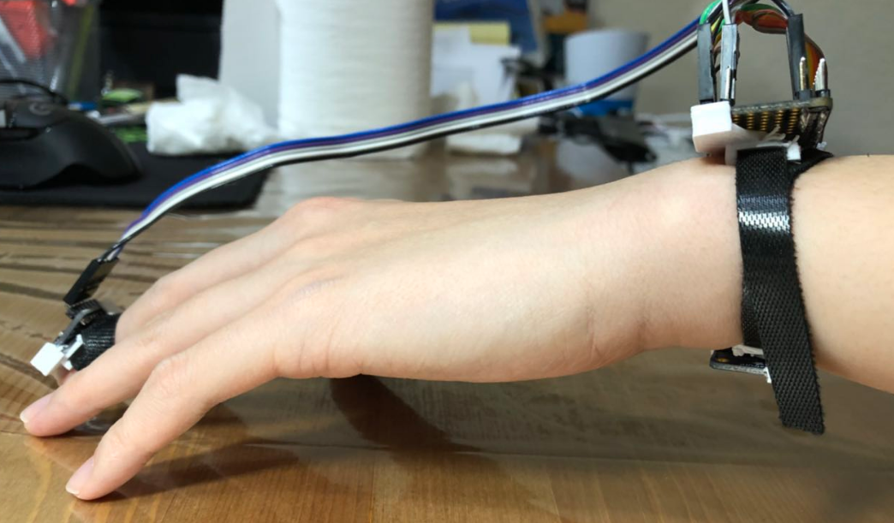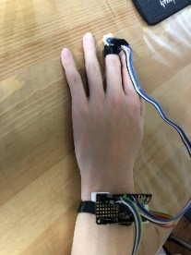
Figure 1. Illustration of the hand tremor sensors.

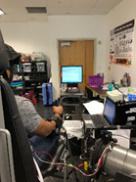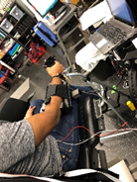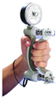
Figure 2. Position of the participant during the measurements and hand dynamometer.

Forearm EMG was recorded with ………………

The displacement amplitude (cm) was estimated by dividing the acceleration amplitude by the squared tremor frequency in radians per second.???????

Procedure
The experiment was take place in a quiet/private lab environment at TAMU-USA. During the experimentation, participants were seated comfortably on a chair (Fig. 2). All experimental procedures were performed by appropriately trained and credentialed personnel, following Standard Operating Procedures (SOP). The participants were wearing the accelerometer fixed ring to the terminal phalanx of the index finger and accelerometer fixed wristband. Subjects were asked to estimate the intensity of exercises using Rated Perceived Exertion (RPE) scale (1-10) and whether their left- or right-hand is dominant.
Tremor was assessed in three stages (Fig. 3). In the first stage, Pre-Fatigue test (~3 min), the participants were test in three conditions: rest (resting tremor), unloaded posture (posture tremor), and loaded posture (posture tremor) positions. In the rest position, the participant’s forearm was fully supported with the hand and fingers completely relaxed so that there was no voluntary muscle activity in the forearm and hand. In the postural condition, the participants were asked to raise their dominant arm horizontally in front of them, parallel to the floor by maintaining a flexion of 90° at the shoulder, an extension of the elbow, pronation of the forearm and an extension of the index finger while the other fingers remained at rest. In the loaded postural condition, the postural tremor when participants were holding 300 g weight (Jamar Hydraulic Hand Dynamometer) in the distal half of their horizontally extended hand was measured. Each exercise was with duration 15 s followed by 30 s rest.
The second stage, Fatigue test (~10 min), started with Pre-maximum voluntary contraction (MVC) 3 times repeated exercise (5 s followed by 60 s rest). For the Fatigue test, a hand dynamometer was used. The fatigue tasks, a sustained contraction at 30% MVC, consist of the repetition of 30% MVC exertion (15 s) and 15 s rest towards muscle fatigue. The RPE is performed every 4 minutes and at the end of exhaustion.
In the third stage, Post-Fatigue test (~3 min), a cycle which consists of Post-MVC (5 s), posture, resting and loaded posture condition tests each with duration 15 s without rest between exercises was repeated 4 times. The rest period after each cycle of the tasks was progressively increased from 0, 2 and 4 min. The tremor was measured 0, 1, 5 and 10 min after the exhaustion. In this stage, the participant performed the RPE before and post-MVC after 1, 5 and 10 min tasks.

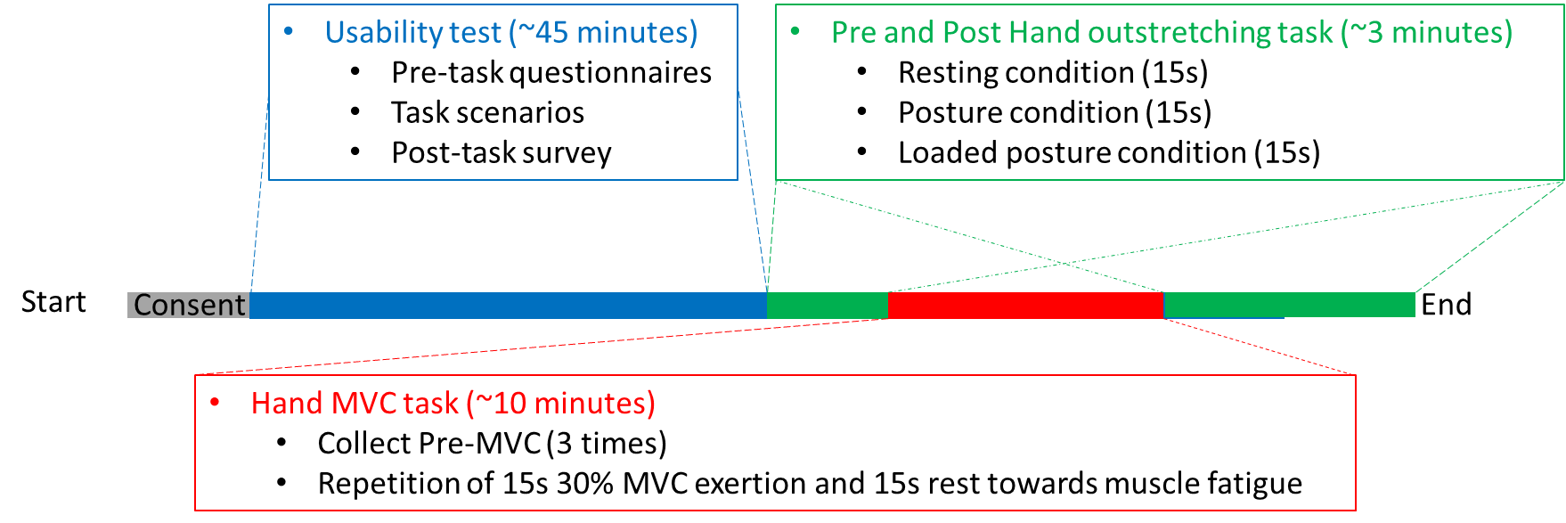
Figure 3. Fatigue tremor protocol.

Data analysis all written in this part should be checked
The accelerometers output voltage signals were sampled at 100Hz, digitized using a 14-bit ADC and fed to microcontroller in the wristband transmitter. The signal was sent to computer for signal processing.
All signals were processed using Matlab (release 2011a; The MathWorks, Natick, MA). The acceleration data was synchronized with EMG event markers and split into episodes (~65 episodes per person) according to event markers. Fast Fourier transforms (FFTs) were calculated for acceleration and rectified EMG (voluntary and mechanical conditions only) at a resolution of 0.12 Hz using Neuro-Spec-software for Matlab (version 2.0, 2008; for a theoretical framework, see Halliday et al. 1995).
Acceleration data was sampling at frequency 45 Hz and after that high pass filter was applied to remove DC frequencies (remove static content).

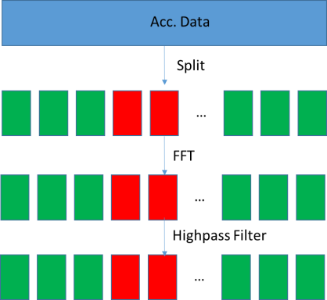

Tremor amplitude was calculated as the root mean square acceleration (RMS) of the tremor signal (ms⁻²) over 0-50Hz frequency spectrum.
Tremor frequency was computed from the EMG and acceleration autospectra.

…………………………..

+EMG data

PSD Distribution: Distribution₈₋₁₄ = PSD₈₋₁₄/PSD_{all} x 100

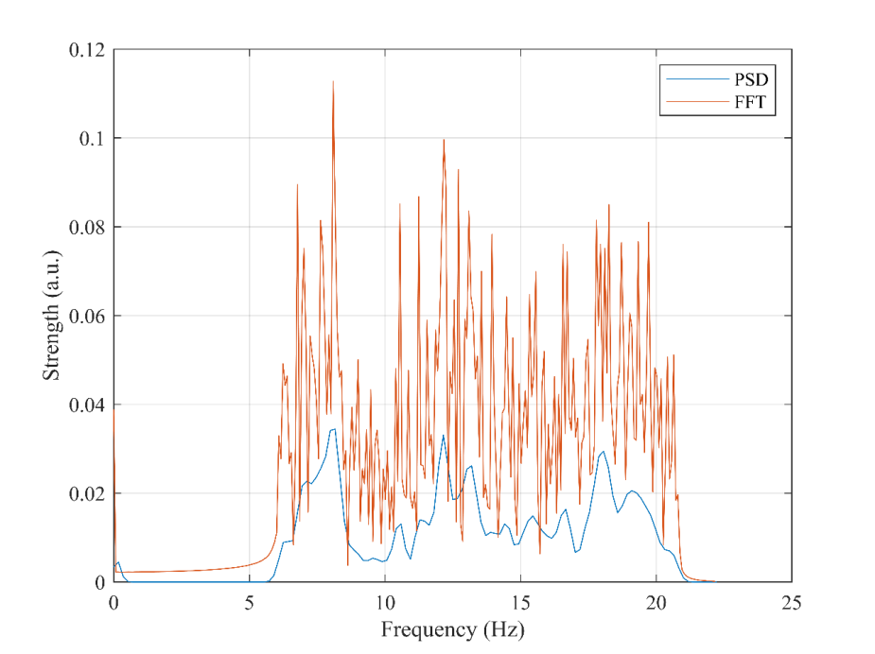
Smoother than FFT
Welch’s Method
The peaks remain the same.

results and discussion

Pre-Fatigue
For pre-fatigue conditions, the average RMS tremor amplitude (RMS values, peak power) and its variance at the finger are greater than at wrist (Figs. from p.6, New figs or some values).
The frequency analysis revealed tremor with higher frequencies of the finger comparing with the wrist in rest, posture and loaded posture condition (figs from p.7, New figs).
The PSD distribution analyses in the 3-8; 8-14 and 14-22 Hz intervals show that most of the peaks are in the first frequency range, especially for the finger tremor. For rest condition, the values for PSD distribution are 48 % (finger) and 38 % (wrist), 30 % (finger) and 33 % (wrist), 18 % (finger) and 24 % (wrist) in the 3-8 Hz, 8-14 Hz and 14-22 Hz ranges, respectively. For posture and loaded posture condition, these values are 49 % and 41 % (3-8 Hz), 26 % and 30 % (8-14 Hz), 19 % and 30 % (14-22 Hz); 54 % and 30 % (3-8 Hz), 24 % and 34 % (8-14 Hz), 18 % and 31 % (14-22 Hz) for finger and wrist, respectively (values from figs from p.3-5, New fig). In case of rest condition, the variance of the PSD distribution on finger tremor is bigger than on the wrist in all three frequency ranges. When the participants do posture and loaded posture condition, the variance of the wrist is almost equal or bigger than of the fingers, which could be explained with their physical status and ability to do simple exercises without fatigue.
For the finger tremor in rest and posture condition, the most notable changes of the post-fatigue mean PSD distribution and its variance are in the 3-8 Hz range.

Post-Fatigue
As each person has an individual level of fatigue the variance of the amplitude depends on personal physical condition. Exact after the exercises (0 min), the mean tremor’s amplitude is almost the same as the pre-fatigue amplitude for finger and wrist in rest, posture and loaded posture conditions (figs from p.6, New figs) but changes their mean PSD distribution (figs from p.3-5, New fig).
As the participants continue with the exercises in posture and loaded posture condition, their fatigue increase. As the rest time 1 min after the fatigue in rest condition case is 0 s, the finger and wrist fatigue are most notable which is proved by the max variance of the tremor amplitude while the mean PSD distribution is almost the same. The rests after the second and third post MVC are 120 and 240 s, respectively. This gives the opportunity of the participants to rest and the mean PSD distribution and its variance weakly decrease.
For PSD distribution in rest, posture and loaded posture conditions, the variance of the mean post-fatigue value is ± 5% compared with the pre-fatigue value (figs from p.3-5, New fig). These small variances do not allow determining the fatigue influence on the PSD distribution.
For the rest, posture and loaded posture conditions, the tremor can be detected better on the finger as around 50 % of the tremors are in 3-8 Hz range, which makes them easier do detect comparing with the tremor in the rest 2 ranges.??????

MVC and 30% MVC
In pre and post MVC case, the fatigue influence on the tremor amplitude is more notable on finger than on the wrist tremor as well as for the pre and post 30 % MVC (figs from p.6, New figs).
Observing the first five and last three 30 % MVC, the PSD distribution is more than 50 % for the finger and wrist when in the frequency range 8-14 Hz. For the rest two ranges, the values are between 20 and 30 %. (figs from p.1, New figs)
All participants do 3 cycles of MVC with 60 s rest between them. It seems that this time is not so short and the finger and wrist mean PSD distribution changes weakly.

The post MVC cycles include consecutive execution of rest, posture and loaded posture condition. The rest time increase from 0 to 4 min 1 min. From the fig. (figs from p.2, New figs), can be noticed that the range 8-14 Hz mean PSD distribution increase between post 1 min and post 5 min as the fatigue increase. The decreasing in the interval post 5 min to post 10 min shows that the number of tremors with frequency 8-14 Hz also decrease at the expense of tremors in the 3-8 Hz, which are typical for the rest condition. These changes are not so notable for wrist tremor.
For the MVC and 30% MVC conditions, the tremor can be detected better on the wrist because the mean PSD distribution values in the 8-14 Hz range are with almost 20 % bigger than values in the 3-8 and 14-22 Hz, i.e. the main part of the tremors is with frequency typical for physiological tremor??????
There is not founded any dependence of the rest and action tremor frequency or amplitude on the gender of participants as well as on their age.

conclusions

Acknowledgment
The preferred spelling of the word “acknowledgment” in America is without an “e” after the “g”. Avoid the stilted expression, “One of us (R.B.G.) thanks . . .” Instead, try
“R.B.G. thanks”. Put applicable sponsor acknowledgments here; DO NOT place them on the first page of your paper or as a footnote.

References

